**PART 1**

1. **SQL Syntax:**

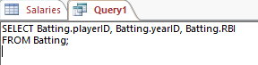

1. **SQL Syntax:**

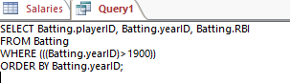

97751 Records are returned

1. **SQL Syntax:**

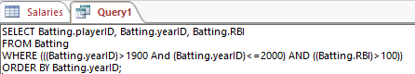

1237 records were returned

1. **SQL Syntax:**

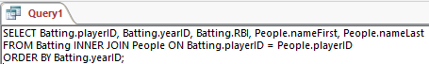

**Table**:

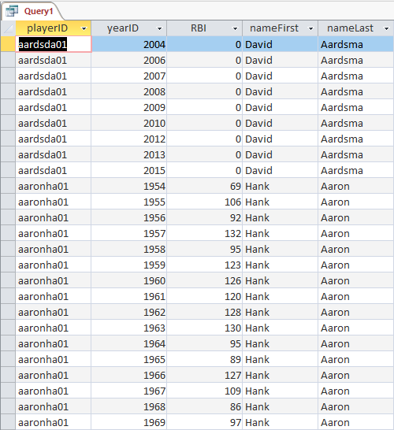

1. **SQL Syntax**:

**Table**: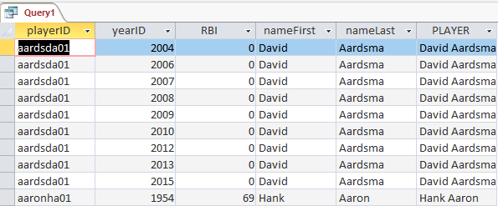

1. **SQL Syntax:**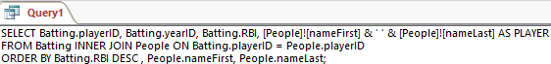

**Player with highest RBI:**

Hack Wilson in 1930 with an RBI of 191

1. **SQL Syntax:**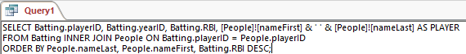

**Hank Aaron’s best season:**

1957, with an RBI of 132

1. **SQL Syntax:**

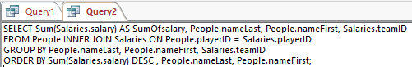

**Which player was payed the most during his play for which team? For how much?**

Alex Rodriguez $320389252 by NYA

1. **SQL Syntax:**

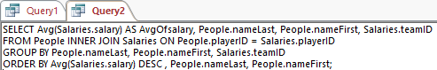

**Which player was payed the annually for which team? For how much?**

Zack Greinke was payed $31799030 per average by ARI

1. **SQL Syntax:**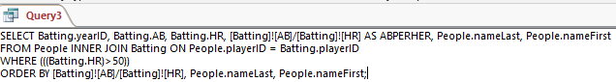

**Which player had the lowest AB/HR? In which year? What was the value?**

Barry Bonds had 6.52 in 2001

1. **SQL:**



**Grid:**

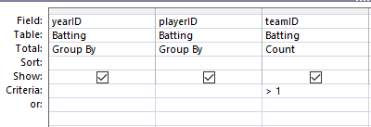

1. **SQL Syntax:**
2. **SQL Syntax:**

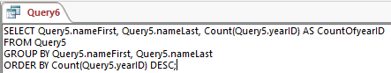

**How many players switched teams mid-season?**

5182

**Which player switched teams most frequently and how many times?**

Bobo Newsom switched teams 8 times.

**PART II**

1. **What is the analogous clause/syntax of find (the corresponding query syntax is find() in MongoDB statement) in the standard SQL query?**

SELECT * FROM shipwrecks WHERE “watlev” == “always dry”

1. **What is the smallest longitude value in the documents?**

-170.6885448

1. **How many documents have the attribute watlev with a value “always dry”?**

2329

1. **How many shipwrecks (with a latitude < 10 degrees) occurred in each different water levels?**

"always dry”: 17,

"covers and uncovers": 1,

"always under water/submerged": 30,

"partly submerged at high water": 4

1. **How many shipwrecks occurred within the latitude rang 0 and 10?**

37

1. **What is the calculated distance?**

162.21153787868622

**What are the coordinates of the shipwreck closest to the target shipwreck?**

-79.9074173, 9.3560572

**7. How many documents have a temperature value below -3 degree?**

287

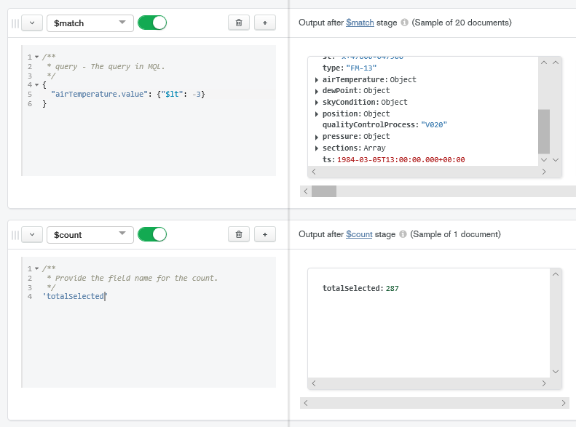

1. **How many documents have pressure value between 1000 and 1030?**

**7601**

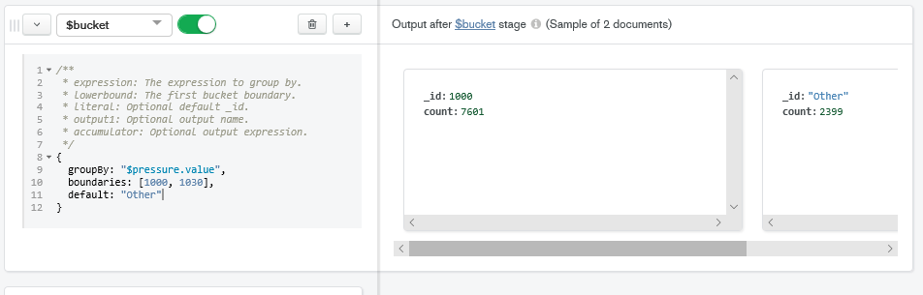

1. **What are the coordinate values of the document that is closest to the document with coordinates 0: 11.8 and 1: 68.4, where 0 indicates latitude and 1 indicates longitude?**